# This article is about the OT-One.

## **It's no-longer sold or actively supported by Opentrons, but we've kept this article here to help existing users. Please** [**see our OT-2 Support articles**](https://support.opentrons.com/) **for the most up to date information!**

Once you've [downloaded](http://support.opentrons.com/getting-started/how-to-run-protocols/downloading-protocols) and [loaded](http://support.opentrons.com/getting-started/how-to-run-protocols/load-and-run-your-first-protocol) your protocol into the OT App, a list of all of the containers needed for your protocol will pop up. Each of these needs to be calibrated before your protocol can run. The list is populated based on which container you should calibrate first.

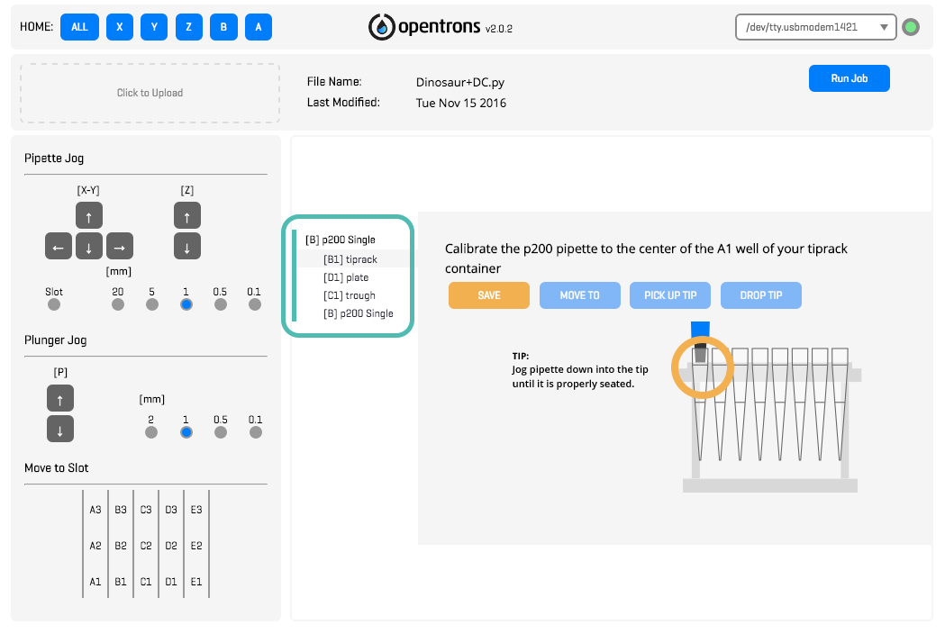

Use the pipette jog section to move the pipettes around the deck.

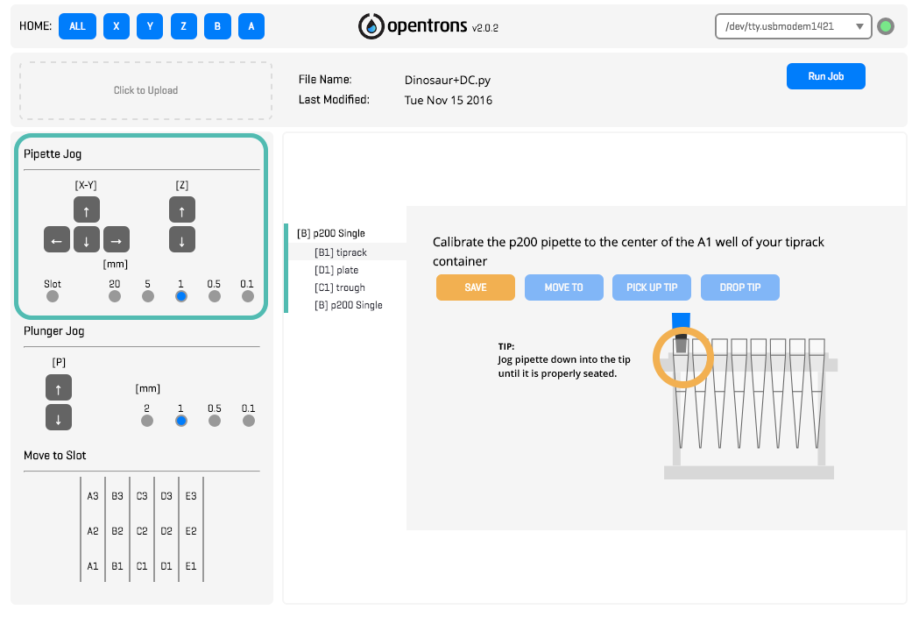

Select the movement increments (in mm), and then click the grey arrows in the direction you want to move. You can use the X, Y and slot increment buttons to move one slot width in the X, or slot depth in the Y direction.

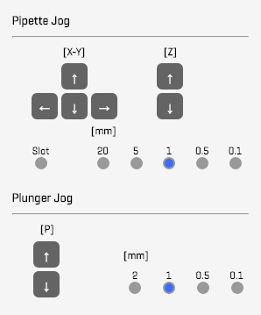

Instead of having to click the arrow buttons for every jog step, you can also use the following keyboard shortcuts:

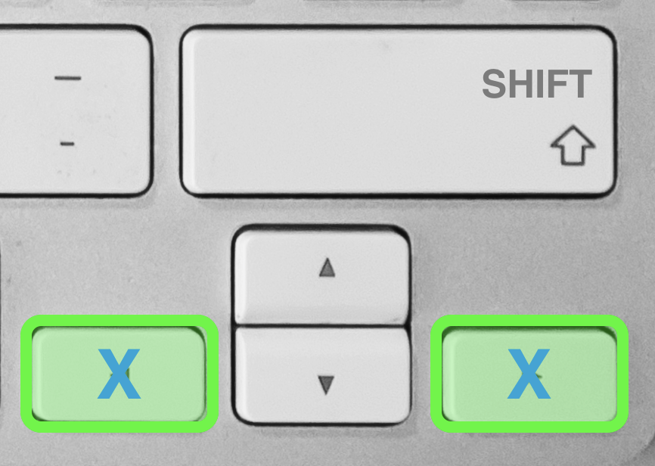

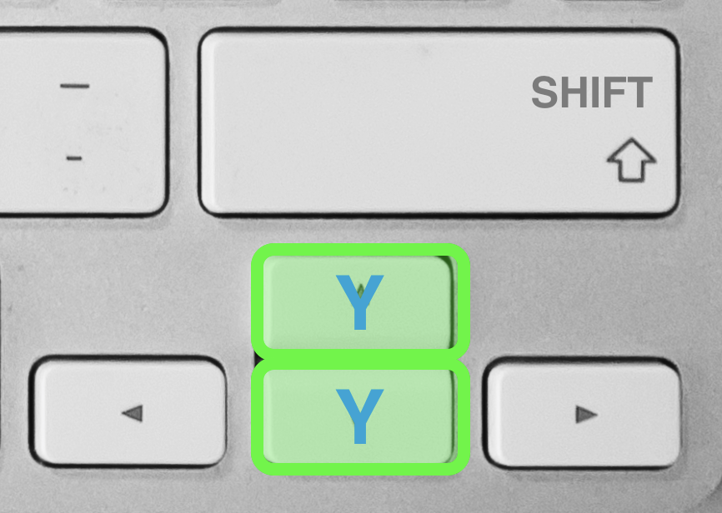

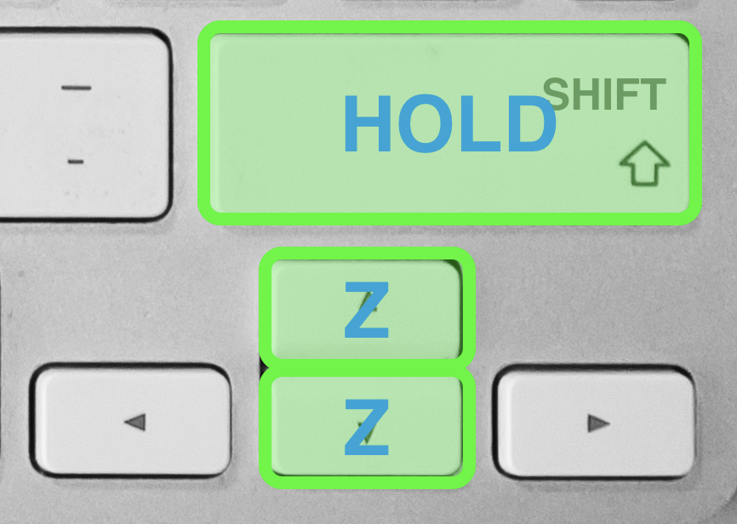

Each piece of labware has specific instructions on how to calibrate within the app itself, so use the pictures on the app as a reference on where and how to correctly calibrate each container.

# Calibrating the Tip Rack

Let's begin by selecting and calibrating a tip rack from the app’s container list:

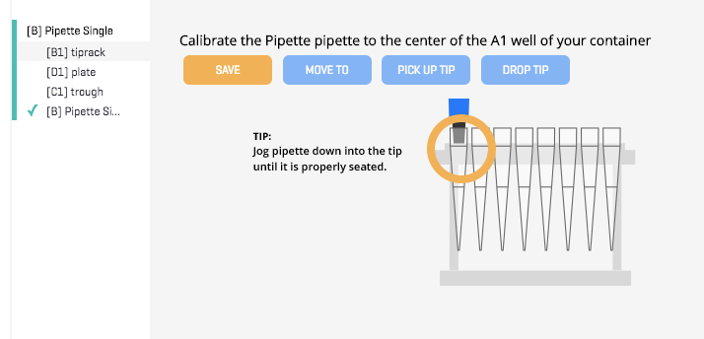

For all tip racks, the OT-One must have it’s pipette inside of the tip in the lower left corner (Designated as Tip “A1” in the very first/front row of the tip rack), such that it is creating a seal by being properly seated.

Saving a tip rack calibration position involves the following steps:

1. Use the jog buttons to move the pipette inside tip “A1”
2. Once properly seated inside the tip, press the “SAVE” button
3. Test the saved position by pressing home “ALL”, then press the "MOVE TO" button. The robot should move to the recently saved position.
4. After you've saved [pipette calibrations](http://support.opentrons.com/getting-started/how-to-calibrate-containers-and-pipettes/calibrating-the-pipettes), click the "PICK UP TIP" and "DROP TIP" buttons on the tip rack calibration screen to make sure the pipette accurately picks up and drops the pipette tip.

**If you need to correct your calibration, hit "SAVE" again, and it will overwrite the previously saved position. Once you have a saved calibration position for a container, a green check mark will appear next to the container name.

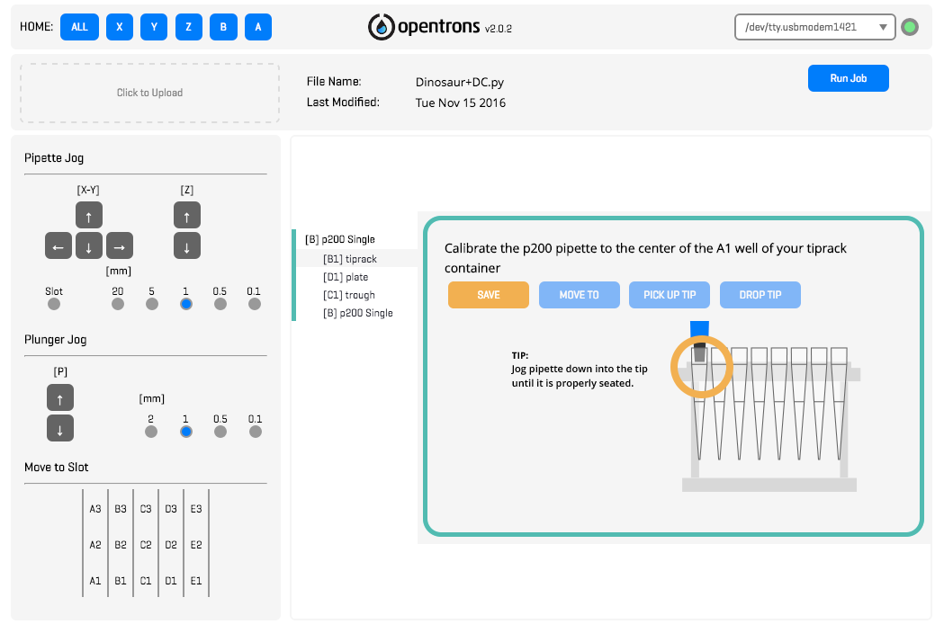

# Calibrating other containers

Next, you need to save the position of all the other containers needed for your protocol. Let's select and calibrate the 'plate' from the container's list in the app.

All other containers must be saved with a tip currently attached to the pipette, so add one now if you need to.

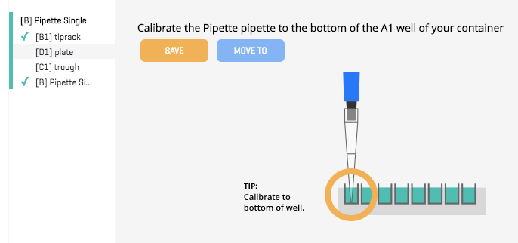

Saving a 'plate' container involves the following steps:

1. Use the jog buttons to move the pipette to the center and bottom of the plate's lower left well ("Well A1")
2. Once properly inside the well (as depicted in the app), press the “SAVE” button
3. Test the saved position by pressing home “ALL”, and then “MOVE TO” on that container.

Repeat for all other containers you may have for your protocol.

# Deck Slot Movements

One way to quickly move the robot to certain deck slot positions is to use the "Move to Slot" buttons in the bottom left corner of the app. The robot will jump around the deck for easy and quick access to container slots.

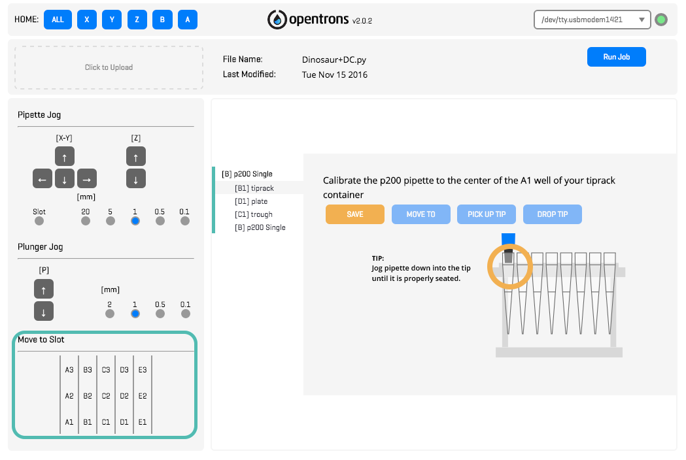

Once all of your labware containers are calibrated, make sure to also calibrate your [pipette(s)](http://support.opentrons.com/getting-started/how-to-calibrate-containers-and-pipettes/calibrating-the-pipettes)!